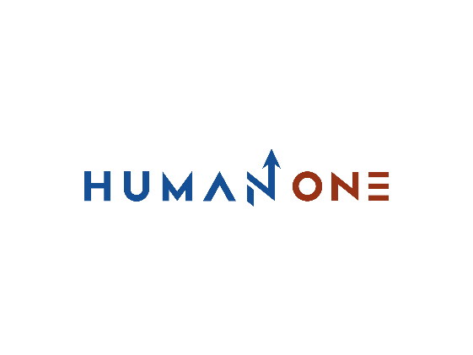

Services

Expertise

**EN**

**FR**

Get in touch

Company

Services overview

Consulting

Engineering

Technology

# Advanced Technology Engineering



HumanOne helps you integrate the technological revolutions brought about by AI and Big Data. Promised to evolve at a rapid pace, the respective exponential growth of these two technologies is about to meet, allowing each to develop even more rapidly.

Aware of the attraction of these technologies and their growing interest, we will guide you to better use them in your solutions and their deployment in your different structures.

Let’s Talk

# What we do



Emerging Technologies

Develop the best solutions for the future with the most advanced emerging technologies



Internet of Things

Enhance the commercial attractiveness of connected devices



Artificiel Intelligence

Designation and configuration of your solution by integrating AI-based specificities



Data Engineering

Developing your upcoming solution by structuring and elaborating its data

# 

**Data Engineering**

* Data restructuring
* Checking the feasibility of the project
* Designing the overall shape of your solution

**Artificiel Intelligence (AI)**

* Designing the AI solution
* Delivering a first AI based prototype
* Implementing the new AI solution

**Internet of Things**

* Drawing up the full cycle IOT development
* Engaging the IOT acceleration
* Developing the IOT software

**Emerging Technologies**

* Fixing the digital twins
* Elaborating the new vision through computing
* Installing the blockchain

# What you get



Better restructuring of your data will lead to better business decisions.



Increase efficiency and automation of operations with better, more advanced data management



HumanOne delivers engineering solutions based on the new possibilities of advanced technologies (AI, machine learning, Big Data, IoT, and others).

## **Digital consulting highlights**



By leveraging sophisticated automation practices and improved quality of execution, you will achieve better business results and expand your capabilities while controlling costs



Formulate a better response to your company's aspirations by relying on innovative and customized technological solutions, developed with the expertise of top engineering executives.

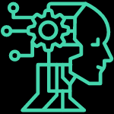

Facilitate your decision making for better predictive analytics, leveraging the capabilities of advanced technologies to create and sustain business value.

A set of best innovative technologies

A tailored Approach vision

An optimized continuous improvement

With HumanOne, take the path of innovation with the most advanced technologies.

Get in touch

## **Why HumanOne**

**An innovation focused strategy**

By selecting the most efficient and emerging methodologies among the latest trends, we give pride of place to innovation at scale to enable companies to keep up to date, create new value and retain it.

**International standards**

HumanOne deploys all of its resources to develop effective, high-quality solutions. With HumanOne you choose a partner that is aligned with quality standards such as ISO 27001:9001, GDPR, A-SPICE. We favor solutions developed with the best practices in our industry and around the world.

**International standards**

HumanOne deploys all of its resources to develop effective, high-quality solutions. With HumanOne you choose a partner that is aligned with quality standards such as ISO 27001:9001, GDPR, A-SPICE. We favor solutions developed with the best practices in our industry and around the world.

**A mastery of the art of end-to-end engineering.**

We manage the entire software development process, from determining the specifications, to writing and testing the code, to organizing production. At HumanOne, our efficient processes and domain expertise ensure continuous quality and predictability.

**An in house development**

We develop in-house concepts elaborated with AI. In production processes. By integrating AI in CRM, service companies or product sales companies benefit from better commercial and financial performance, for the development of chatbots for customer management for example.

**A result-oriented approach.**

We develop solutions in close cooperation with our customers to elaborate the requirements, to retrieve the most efficient solutions. In this way, we deliver a solid product that meets your most demanding requirements.

**Scalable implementation**

HumanOne is able to quickly implement its clients' projects thanks to the quality of its engineering experts. We are constantly working to improve our engineering capabilities

